***Practical 4***

Aryaman Gautam

J001

1. Input serial monitor and control inbuilt LED

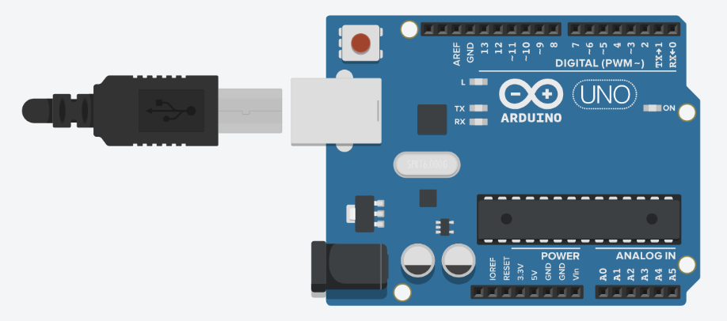

int n; /* for user incomming character (1/0)*/

void setup() {

Serial.begin(9600);

pinMode(13,OUTPUT);

}

void loop() {

/*getting serial input from serial monitor*/

if (Serial.available()){

n=Serial.parseInt(); /*parseInt() used to accept string (such ASCII)and convert it into an integer*/

Serial.print(n);

if (n==1)

digitalWrite(13,HIGH);

else if (n==0)

digitalWrite(13,LOW);

}

}

1. Input from serial monitor and control the external LED

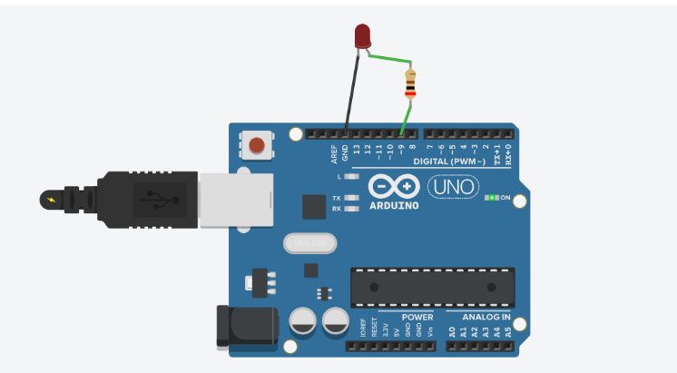int n; /* for user incomming character (1/0)*/

void setup() {

Serial.begin(9600);

pinMode(9,OUTPUT);

}

void loop() {

/*getting serial input from serial monitor*/

if (Serial.available()){

n=Serial.parseInt(); /*parseInt() used to accept string (such ASCII)and convert it into an integer*/

Serial.print(n);

if (n==1)

digitalWrite(9,HIGH);

else if (n==0)

digitalWrite(9,LOW);

}

}

1. Intensity of light using photoresistor

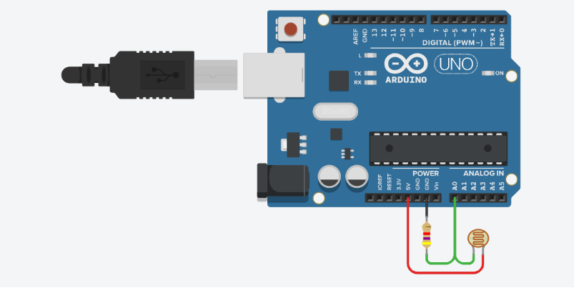void setup()

{

pinMode(A0, INPUT);

Serial.begin(9600);

}

void loop()

{

int sensorReading = analogRead(A0);

Serial.println(sensorReading);

delay(10);

}

1. Rotate servo motor by 45 or 90 degrees

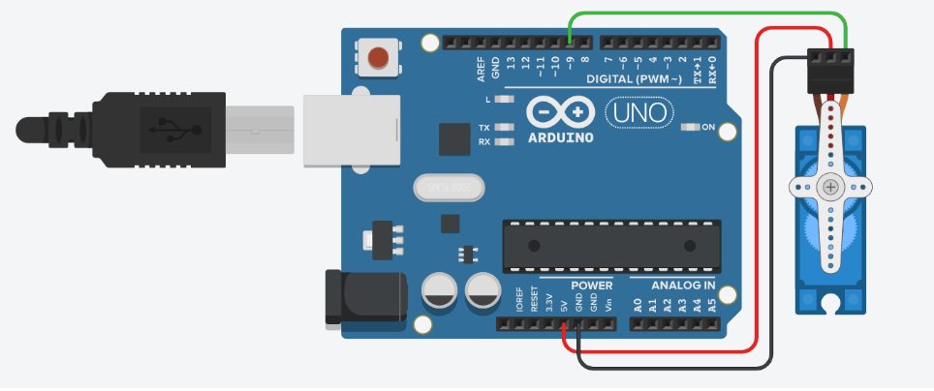

#include <Servo.h>

int pos = 0 ;

Servo servo_9;

void setup()

{

servo_9.attach(9, 500, 2500);

}

void loop()

{

servo_9.write(45);

delay(500);

servo_9.write(90);

delay(500);

}

1. Photoresister or LDR or photo varister to control LED

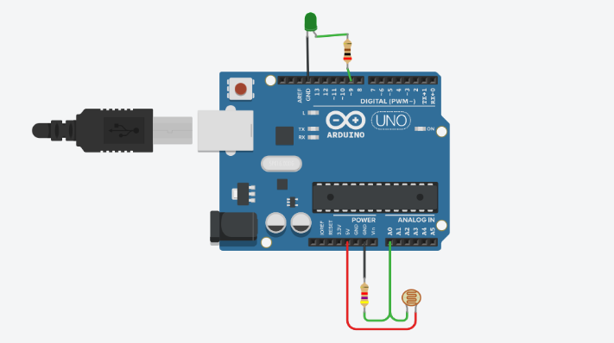

void setup()

{

pinMode(A0, INPUT);

pinMode(9, OUTPUT);

Serial.begin(9600);

}

void loop()

{

int sensorReading = analogRead(A0);

Serial.println(sensorReading);

int modifiedSensorReading = map(sensorReading,26,923,0,256);

analogWrite(9,modifiedSensorReading);

delay(10);

}

1. If button is pressed servo will rotate 180 and return to 0

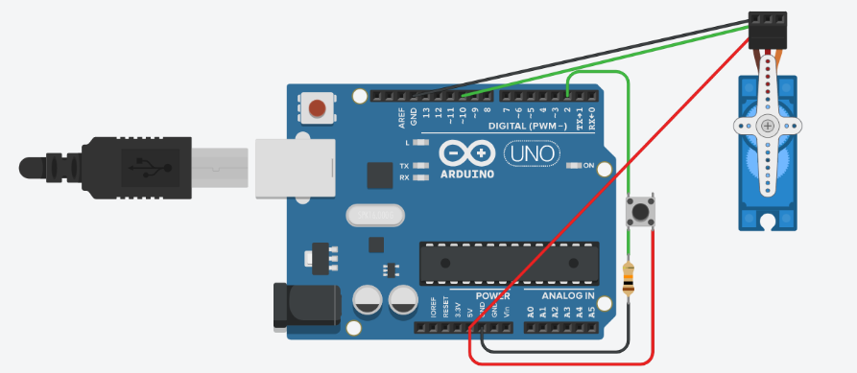

#include<Servo.h>

int buttonState = 0;

Servo myservo;

int val;

void setup()

{

pinMode(2, INPUT);

pinMode(13, OUTPUT);

myservo.attach(10);

}

void loop()

{

int buttonState = digitalRead(2);

if (buttonState == HIGH) {

val=180;

} else {

val=0;

}

myservo.write(val);

delay(10);

}

1. Control servo shaft using potentiometer

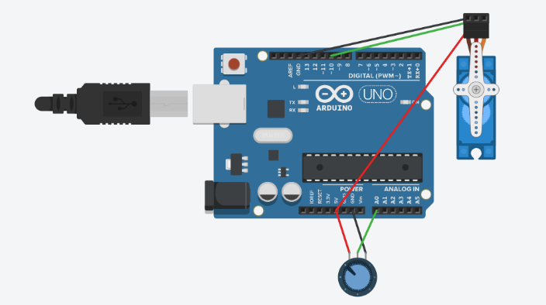

#include<Servo.h>

Servo myservo;

int sensorValue = 0;

void setup()

{

pinMode(A0, INPUT);

pinMode(13, OUTPUT);

myservo.attach(10);

}

void loop()

{

delay(100);

sensorValue = analogRead(A0);

myservo.write(sensorValue);

delay(10);

}

1. Rotate servo from 0 to 180 and back to 0,by changing shaft angle by 1 degree every 10ms

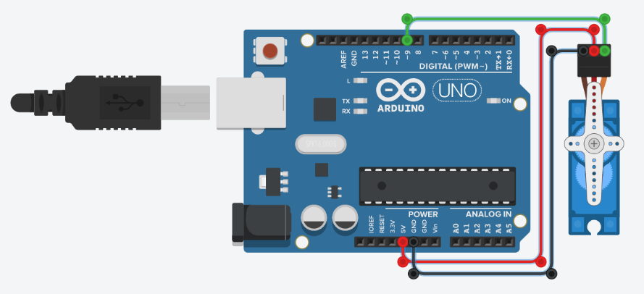

/*

Sweep

by BARRAGAN <http://barraganstudio.com>

This example code is in the public domain.

modified 8 Nov 2013 by Scott Fitzgerald

http://www.arduino.cc/en/Tutorial/Sweep

*/

#include <Servo.h>

int pos = 0;

Servo servo_9;

void setup()

{

servo_9.attach(9, 500, 2500);

}

void loop()

{

// sweep the servo from 0 to 180 degrees in steps

// of 1 degrees

for (pos = 0; pos <= 180; pos += 1) {

// tell servo to go to position in variable 'pos'

servo_9.write(pos);

// wait 15 ms for servo to reach the position

delay(10); // Wait for 10 millisecond(s)

}

for (pos = 180; pos >= 0; pos -= 1) {

// tell servo to go to position in variable 'pos'

servo_9.write(pos);

// wait 10 ms for servo to reach the position

delay(10); // Wait for 10 millisecond(s)

}

}

1. Open the door when bell is heard on button press

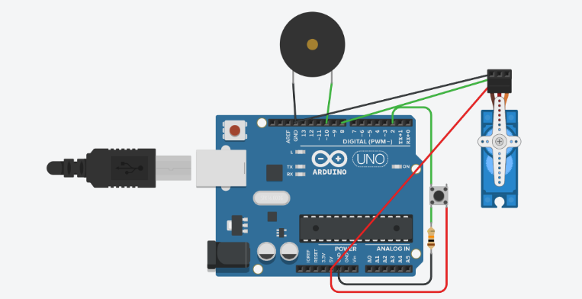

#include<Servo.h>

int buttonState = 0;

Servo myservo;

int val;

void setup()

{

pinMode(2, INPUT);

pinMode(10, OUTPUT);

myservo.attach(8);

}

void loop()

{

int buttonState = digitalRead(2);

if (buttonState == HIGH) {

tone(10,250);

val=90;// door opening at 90 degree

delay(10);

noTone(10);

}

else {

val=0;

}

myservo.write(val);

delay(10);

}

1. When traffic signal is red, door is closed and traffic signal is green, then door should open

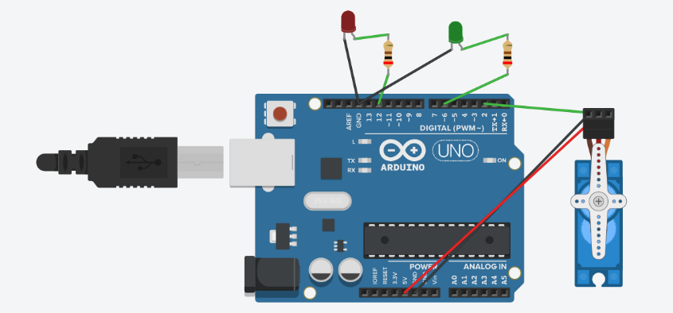

#include<Servo.h>

Servo myservo;

void setup()

{

pinMode(6, OUTPUT);// green

pinMode(12, OUTPUT);// red

myservo.attach(2);

}

void loop()

{

digitalWrite(12, HIGH);

myservo.write(0);

delay(5000);

digitalWrite(12, LOW);

delay(500);

digitalWrite(6, HIGH);

myservo.write(90);

delay(5000);

digitalWrite(6, LOW);

delay(10);

}